WORKING WITH MULTIPLEXRS

Task 1

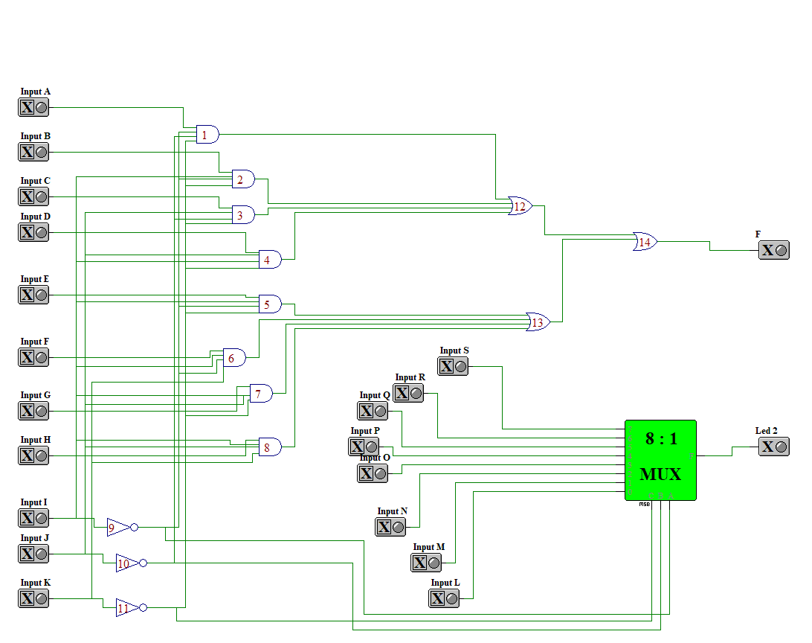

Task 2

